Running the CVI/TestStand Integration Tests

Notes
Please refer to CAR# 637123. If testing with CVI 2012 SP1, please apply the KB here, then execute the tests. Without the work around, Steps 3 and 4 from the Automated tests section cannot be executed.

Preparation
- Install TestStand and CVI
- Start CVI at least once to ensure that it registers its COM server.
- Get tests from Perforce: //TestStand/Tests/CVI Tests. This document refers to this directory as <CVI Tests>.
- Remove the read-only attribute from all files in the <CVI Tests> directory and subdirectories.
- Build the following project and bind to the latest SxS CVI RTE:
  - In CVI, open the project <CVI Tests>\Automated\5.0\CVI SxS\TestCAObjHandlesSxSLatest.prj
  - Set the Configuration to Debug.
  - In the Target Settings dialog, change the Run-time engine binding option to the SxS version of CVI you are testing (e.g. 2012 side-by-side)
  - Build the Dll (debuggable) and save the project.
  - Set the Configuration to Release.
  - In the Target Settings dialog, change Run-time engine binding as you did for the Debug configuration.
  - Save the project and exit CVI.
- Run the batch file <CVI Tests>\Automated\RegisterServerAsAdmin.bat as an administrator to register an ActiveX server that is used by the automated tests.
- Run TestStand Sequence Editor.
- Verify that TestStand CVI Adapter is configured to execute In-Process (Configure >> Adapters):
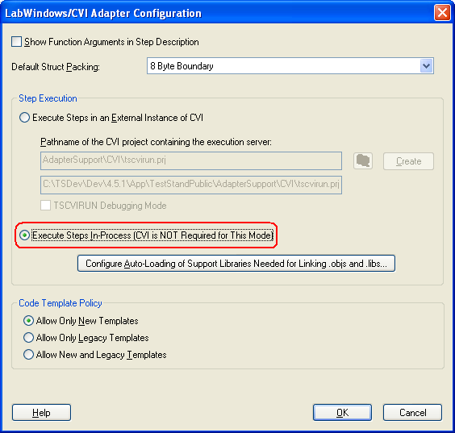

Running Automated Tests
In the instructions below that refer to <AllAutomatedCVITests.seq> you will use one of the following sequence files depending on whether you are testing latest prerelease version of TestStand or the current released version of TestStand:
- Prelease version: <CVI Tests>\Automated\AllAutomatedCVITestsPrerelease.seq
- Current version: <CVI Tests>\Automated\AllAutomatedCVITestsCurrent.seq
Note: When testing with 64-bit, the msvc64 DLLs from projects need to be copied outside the folder, so that the sequence can pick up the 64-bit DLLs.
Follow these instructions to run the automated tests.
- Test older CVI object files using new CVI RTE in Sequence Editor:
  - In the TestStand Sequence Editor, open <AllAutomatedCVITests.seq>
  - Run Single Pass and verify that the test passes.
NOTE: To verify that the test passes, you need only verify that the top-level sequence passes. Some individual steps are expected to fail or error during execution.
- Test older CVI object files using new CVI RTE in TestStand CVI UI:
  - In TestStand CVI UI (<TestStand>\UserInterfaces\Full-Featured\CVI\TestExec.exe), open <AllAutomatedCVITests.seq>
  - Run Single Pass and verify that the test passes.
- Test new Release CVI object files in CVI UI:
  - Before building object files, you must unload all modules in the TestStand Sequence Editor or CVI UI if they are running.
  - In CVI, open <CVI Tests>\Automated\AllAutomatedProjects_Release.cws. Use batch build to rebuild all Release configurations (not Release64).
NOTE: CVI may fail to create the release build for the Testlimitstepslib project for some reason. If this occurs, you’ll have to create a debug build for that project. (Jared reported that the release build worked fine for him with CVI 2010 SP1.)
  - Create object files using Release configuration for the following files. These files should be opened when you opened the workspace. (Use Options>>Create Object File> menu item):
    - <CVI Tests>\Automated\2.0\CVIAdp\CVIAdpTest.prj: CVIAdpTest.c
    - <CVI Tests>\Automated\4.5\flexCVIAdapter\64BitIntegers\64BitIntegersTests.prj: 64BitIntegersTests.c
    - <CVI Tests>\Automated\5.0\CVI SxS\TestCAObjHandles.prj:TestCAObjHandles.c
  - In CVI, open TestStand Public CVI UI project: <TestStandPublic>\UserInterfaces\Full-Featured\CVI\TestExec.prj. Build Release configuration.
  - Execute the TestStand Public CVI UI (<TestStandPublic>\UserInterfaces\Full-Featured\CVI\TestExec.exe) and open <AllAutomatedCVITests.seq>
  - Run Single Pass and verify that the test passes.
- Test new Debug CVI object files in CVI UI:
  - Before building object files, you must unload all modules in the TestStand Sequence Editor or CVI UI if they are running.
  - In CVI, open <CVI Tests>\Automated\AllAutomatedProjects_Debug.cws. Use batch build to rebuild all Debug configurations (not Debug64).
  - Create object files using Debug configuration for the following files. These files should be opened when you opened the workspace. (Use Options>>Create Object File> menu item):
    - <CVI Tests>\Automated\2.0\CVIAdp\CVIAdpTest.prj: CVIAdpTest.c
    - <CVI Tests>\Automated\4.5\flexCVIAdapter\64BitIntegers\64BitIntegersTests.prj: 64BitIntegersTests.c
    - <CVI Tests>\Automated\5.0\CVI SxS\TestCAObjHandles.prj:TestCAObjHandles.c
  - In CVI, open TestStand Public CVI UI project: <TestStandPublic>\UserInterfaces\Full-Featured\CVI\TestExec.prj. Build Debug configuration.
  - Execute the TestStand Public CVI UI (<TestStandPublic>\UserInterfaces\Full-Featured\CVI\TestExec.exe) and open <AllAutomatedCVITests.seq>
  - Run Single Pass and verify that the test passes.
- Test with TestStand CVI Adapter configured to execute in an external instance of CVI.
  - In TestStand CVI UI, use Configure>>Adapters menu to configure the CVI Adapter to execute in an external instance of CVI. (Accept default project for execution server: AdapterSupport\CVI\tscvirun.prj)
  - In CVI, open the tscvirun project (<TestStandPublic>\AdapterSupport\CVI\tscvirun.prj) to configure it for running CVI Tests:
    - Add the following source files to the project:
<CVI Tests>\Automated\2.0\CVIAdp\CVIAdpTest.c
<CVI Tests>\Automated\4.5\flexCVIAdapter\64BitIntegers\64BitIntegersTests.c
<CVI Tests>\Automated\5.0\CVI SxS\TestCAObjHandles.c
    - On the Target Settings dialog, check the Enable LoadExternalModule option, click the Add Files to Executable button and check the tsapicvi.obj and tsutil.obj items and save project:
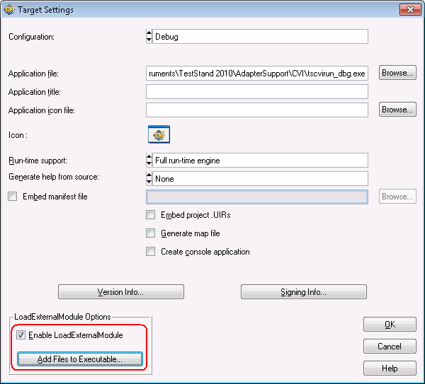
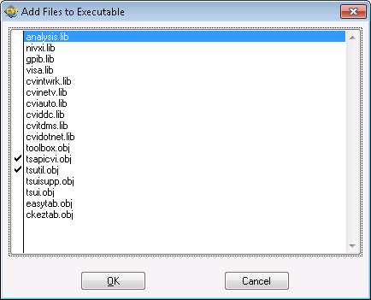

  - In TestStand CVI UI (<TestStand>\UserInterfaces\Full-Featured\CVI\TestExec.exe), open <AllAutomatedCVITests.seq>
  - Run Single Pass and verify that the test passes. (Note: this test will take slightly longer to execute than the previous ones.)

Running Manual Tests
- Edit Code and Create Code
  - In the Sequence Editor, open file <CVI Tests>\Manual\CreateCode\createcode.seq.
  - Select each step individually, display Module settings panel, click the Edit Code button and verify that CVI opens the source file cvi.c and highlights the function name.
  - Select each step individually, change the function name, click the Create Code button and verify that CVI opens the source file, creates the function and highlights the function name.
  - Verify that you can build the CVI project after creating code without errors.
  - Verify that you can run the sequence after creating the new functions.
- Debugging
  - Verify that TestStand CVI Adapter is configured to execute In-Process (Configure >> Adapters). See Preparation at top of this document for screenshot.
  - In CVI open the project <CVI Tests>\Manual\Debugging\debug.prj.
    - Ensure that you have built debug configuration for the above project.
  - Start debugging the Sequence Editor (either start from CVI or attach to already running instance).
  - In the Sequence Editor, open file <CVI Tests>\Manual\Debugging\debug.seq.
  - Set breakpoints in the Sequence Editor and in CVI and test Step Into, Step Out, etc.
- Misc. Tests
  - In the Sequence Editor, open file <CVI Tests>\Manual\AllManualCVITests.seq
  - Run Single Pass. Various dialogs will be displayed and you must close each one manually. The test will also prompt to find the WaveformStepType.dll file. Browse to the <CVI Tests>\Manual\Substeps directory and select the file.
  - In CVI, open the workspace <CVI Tests>\Manual\AllManualProjects.cws
  - Before building object files, you must unload all modules in the TestStand Sequence Editor or CVI UI if they are running.
  - Rebuild all projects (Debug or Release) and repeat test.

